Standards for Electronic Application of Construction Projects in Beijing
(Trial)

Beijing Municipal Commission of Planning and Natural Resources

Table of Contents
Part I General Provisions １
1.1 Purpose １
1.2 Basis １
1.3 Submission of deliverables １
Part II Standards for electronic application materials ２
2.1 Non-drawing documents ２
2.1.1 Requirements for application materials ２
2.1.2 Catalog of application materials ２
2.1.3 Size of electronic files ２
2.1.4 Quality requirements for scanned files ２
2.2 Drawings ４
2.2.1 Requirements for application materials ４
2.2.2 Size of electronic files ５
2.2.3 Notes about BDB file ５
2.2.4 Electronic seals ６

Part I General Provisions
- Purpose
The Standards are formulated in accordance with applicable laws, regulations and standards in Beijing Municipality, to define uniform contents and formats of electronic application materials for deliverables, such as technical documents and planning & design drawings, used for applying the planning permit for construction projects in Beijing Municipality and set standards for materials used for planning application, in an effort to place on file of and build databases for data concerning application materials for planning deliverables.

- Basis
Reference has been made to the following documents and standards as basis during preparation of the Standards:
- Guidelines for Application of Technical Documents for Planning and Design of Construction Projects (Shi Gui Hua Guo Tu Fa[2018] No.87)
- General Rules for Planning and Design of Construction Projects in Beijing Municipality (2003)
- Allocation Norms for Dwelling Public Service Facilities in Beijing Municipality (Jing Zheng Fa [2015] No.7)

- Submission of deliverables
Constructors should make online application at tzxm.beijing.gov.cn when submitting application materials.

Part II Standards for electronic application materials
Electronic application materials should be prepared and compiled pursuant to the technical requirements at the stage of construction project approval in the Guidelines for Application of Technical Documents for Planning and Design of Construction Projects (Shi Gui Hua Guo Tu Fa [2018] No.87). Such materials consist of drawings and non-drawing documents.
- Non-drawing documents
- Requirements for application materials
Non-drawing documents should be scanned into PDF files.
- Catalog of application materials
A catalog of application materials should be compiled based on the list of application materials indicated in the guidelines for handling of relevant businesses. Names of files in such table of contents should be consistent with those of electronic files in PDF and compressed formats.
- Size of electronic files
The size of each PDF file should not exceed 200MB; otherwise the file should be split. Split files should be named by adding suffixes such as -1.pdf and -2.pdf.
- Quality requirements for scanned files
(1) Electronic files should be scanned into PDF files;
(2) Paper materials should be scanned in color with resolution no lower than 100dpi. Each page of a PDF file should be no more than 5MB in size and a multi-page PDF file should be no more than 200MB in size. Scanned files should have the same names with their paper counterparts.
(3) Scanned electronic files should have the same order of pages with paper files.
(4) Such scanned files should be legible when the zoom level is set as 1:1;
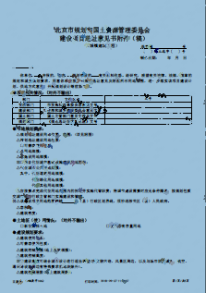 | 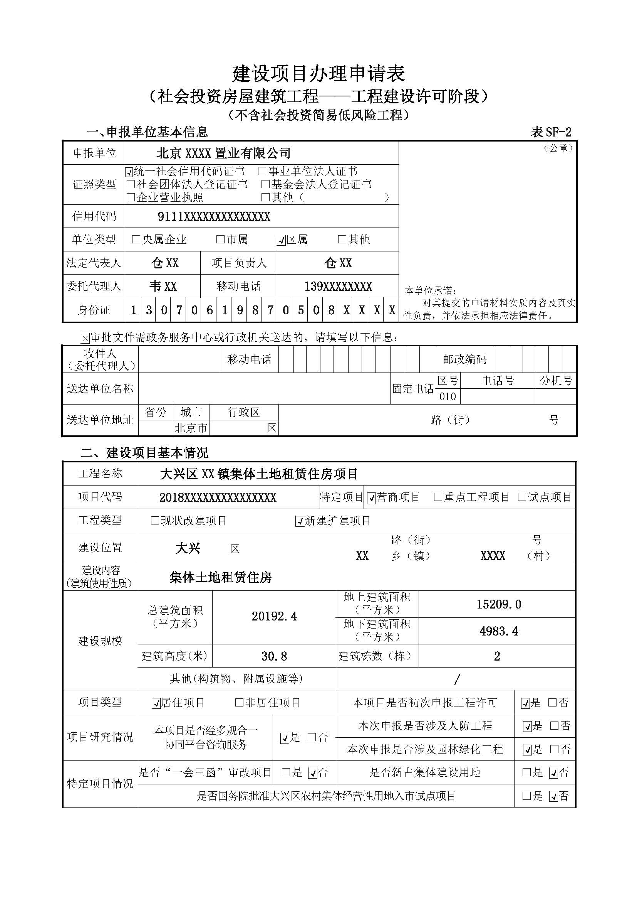
Example of illegible scanned file | Example of legible scanned file

(5) Omission or repetition should be avoided during scanning;
(6) Incomplete scanning should be avoided (such as missing page, part of text or chapter, or deformed text);
Example of incomplete scanned file (missing content and black edge) | Example of accurately scanned file (no black edge with a width over 1mm nor rotation of pages is allowed)

(7) All scanned files should be saved by type in line with the catalog of application materials and one paper document should be saved as one PDF file;
(8) Documents with sheet size larger than A4 should be scanned with a large format scanner or their pages should be split into different parts during scanning and pieced together (if split scanning is used, different parts should be pieced together in an aligned manner, without any gap or asymmetry);
Example of wrong piecing with gap | Example of proper piecing

- Drawings
- Requirements for application materials
(1) All design drawings should be combined into one PDF file. If more than one building is involved, drawings for each building should be scanned separately into one PDF file;
(2) The general layout plan should consist of a BDB file and a PDF file, both with the same name and compressed into a separate compressed file;
Such general plan should be processed in terms of drawing regularity and attribute definition with the 'tool for application of electronic drawings of planning permit' (download address: http://ghzrzyw.beijing.gov.cn/zhengwuxinxi/zxzt/yhyshjbljzxkzt/bszn/202111/t20211105_2530019.html) made available by the Beijing Municipal Commission of Planning and Natural Resources. Detection of key indicators of planning review should also be completed and BDB and PDF files of the same name should be exported.
- Size of electronic files
(1) The size of each PDF file should not exceed 200MB; otherwise the file should be split. Split files should be named by adding suffixes such as -1.pdf and -2.pdf.
(2) The BDB file of the general plan should be placed within the same compressed file (with the suffix of .zip or .rar) with its PDF file of the same name and the size of such compressed file should not exceed 200MB. If the size is larger than 200MB, more than one compressed file is required and should be named by adding such suffixes as -1.zip, -2.zip, -1.rar or -2.rar.
- Notes about BDB file
BDB is the standard format of electronic design drawings designated for application materials for planning of construction projects in Beijing Municipality. Its data composition and relations are as follows:
- As a data file, a BDB file is composed of two parts: geometric information and review indicators, between which exists a relation of linkage and correspondence.
- A BDB file supports data extension and vector data, such as comments from during review, will be added to such a file.
- Electronic seals
Electronic PDF design drawings in electronic application materials for deliverables of construction projects in Beijing Municipality should be sealed with electronic special seals of qualification as required, including designers' special seal of application, seal of qualification of registered architect and seal of qualification of registered structural engineer. Electronic seals should be certified by CA to ensure its effectiveness and integrity.

