Beijing Engineering-geological Survey Information Inquiry Service Platform
V1.0 (Trial)

User Manual

March, 2022

Table of Contents
1 Features and Steps - 4 -
1.1 Home Page - 4 -
1.2 User Login and Registration - 4 -
1.2.1 Login - 4 -
1.2.2 Corporate Registration - 5 -
1.3 Data Retrieval - 6 -
1.3.1 Setting a Base Map - 6 -
1.3.2 Place Name Query - 7 -
1.3.3 Rectangular Query - 8 -
1.3.4 Point Query - 9 -
1.3.5 Line Query - 10 -
1.3.6 Resetting - 11 -
1.3.7 Cleaning Query History - 11 -
1.4 Material Request - 12 -
1.4.1 Data Request - 12 -

Features and Steps

Home Page
Upon you enter the System, you'll see the Home Page, a place where information such as policies, regulations and notices in the System at present are displayed. You can see the full texts of such policies, regulations and notices by clicking on the titles of them. See the following figure for the details of the Home Page:
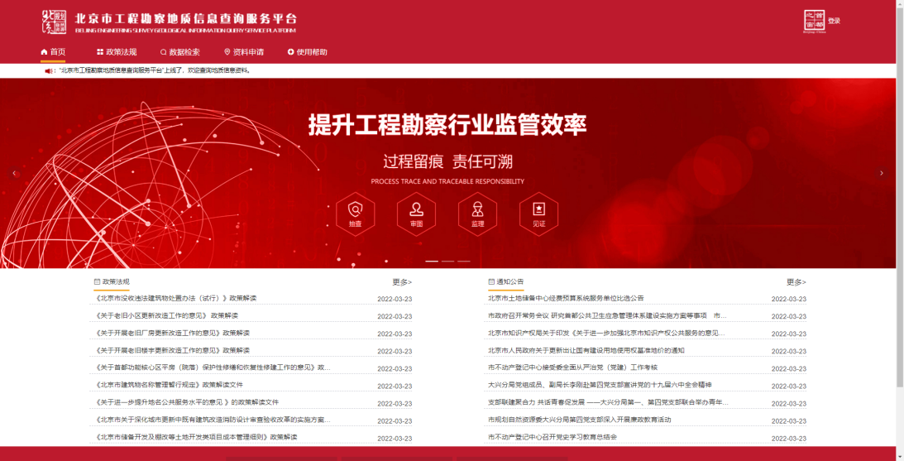
Fig. 1 Home Page

User Login and Registration

Login
Click on the "Login" button at the top right corner of the Home Page, the Login Interface will pop up. Enter your account number, password and verification code, you'll be able to log in. Note that the verification code is case-sensitive. See the following figure for the details of the Login Interface:

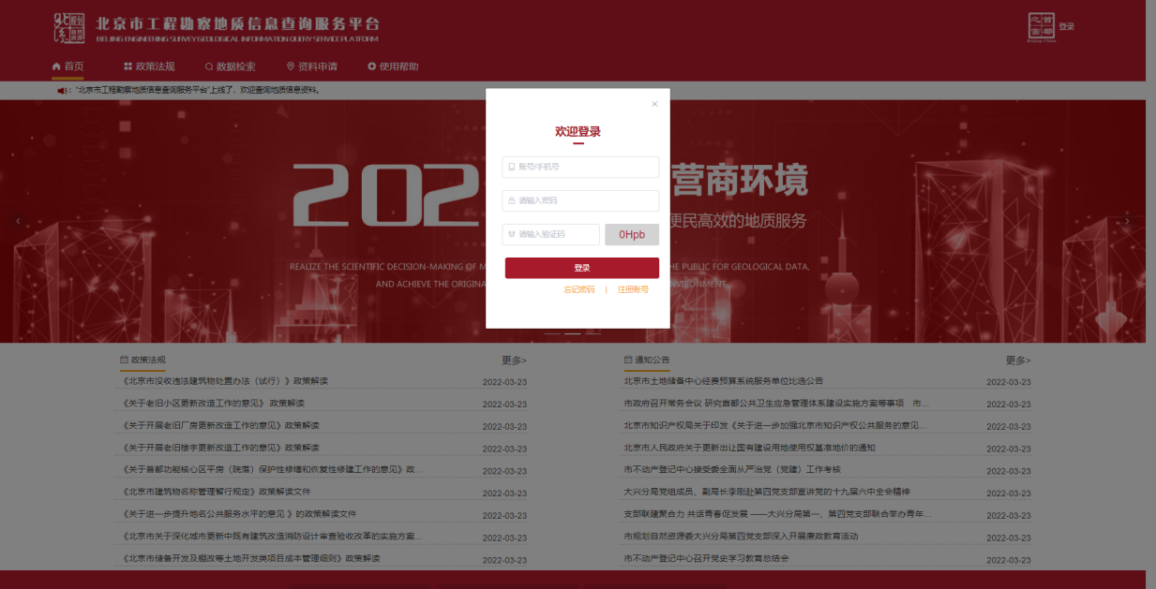
Fig. 2 Login Interface
If you forget your password, click on the "Forgot Password" button at the bottom of the Login Interface, the Password Retrieval Interface will pop up, then put in the information required in the Password Retrieval Interface, you'll be able to change your password. See the following figure for the details of the Password Retrieval Interface:
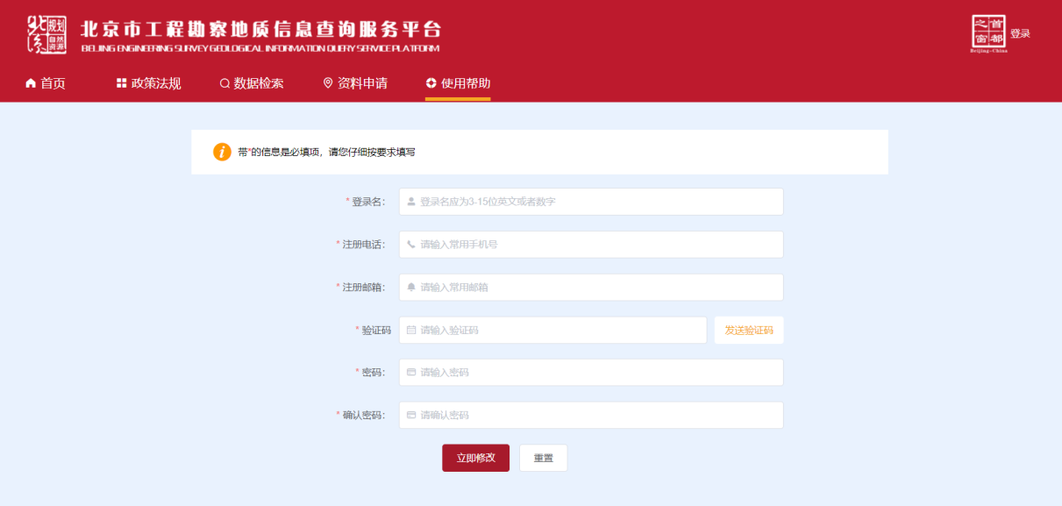
Fig. 3 Password Retrieval Interface

Corporate Registration
Click on the "Login" button at the top right corner of the home page, the Login Interface will pop up. Click on the "Register" button at the bottom right corner of the Login Interface, and put in the information required to get yourself registered.
In the Corporate Registration interface, enter a login name, your phone number, email address, company name, company address, password, the verification code and upload the authentication materials. Note that the verification code is case-sensitive, and the authentication materials include photos of your business license and other materials for examination. When the materials are successfully uploaded, the System will pop up a notification to tell you that it is done. When you put in all the information required, click on the "Apply Now" button. If the System reminds you that the registration is done, you have got your company registered. See the following figure for the details of the Registration Interface:
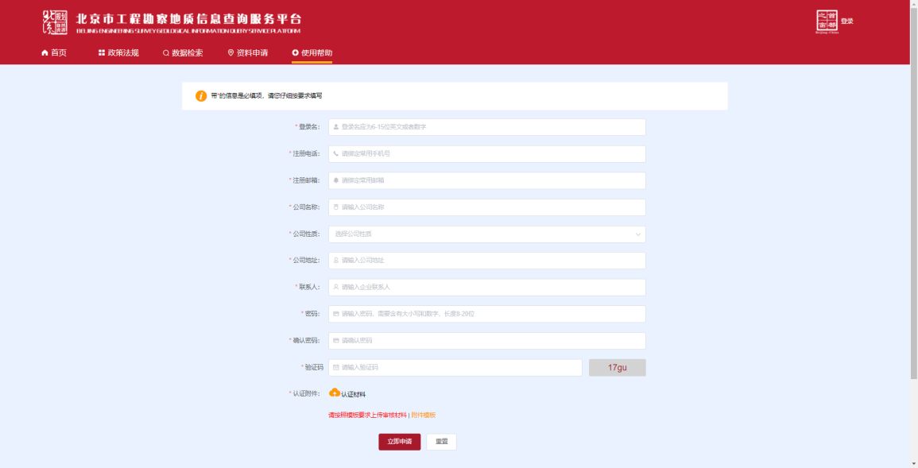
Fig. 4 Corporate Registration Interface

Data Retrieval
Data retrieval page features the functions of setting a base map, place name query, advanced query, rectangular query, point query, line query, resetting and cleaning query history.

Setting a Base Map
The default base map in the Data Retrieval Interface is the map of Beijing and its surrounding cities. It can be switched at the bottom right corner of the Data Retrieval Interface. Alternative base maps include topographic map, satellite map, satellite hybrid and topographic hybrid. You can zoom in or out by scrolling the mouse wheel up and down, or clicking on the "+" and "-" buttons at the top right corner. See the following figure to find out how to set the base map:
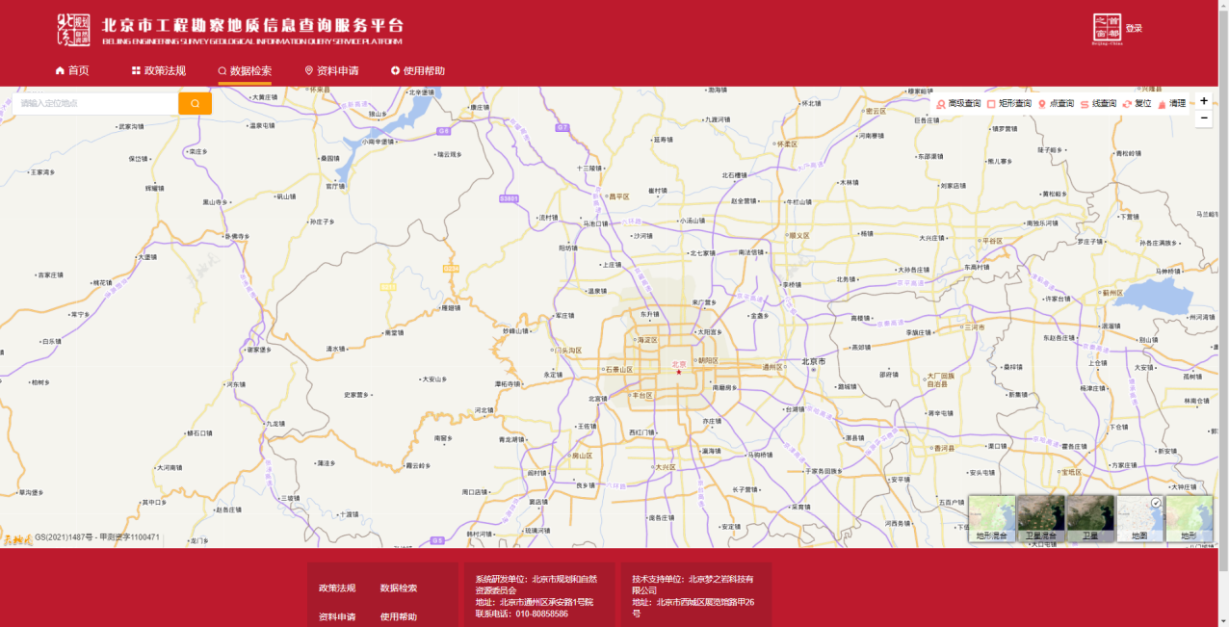
Fig. 5 Setting A Base Map

Place Name Query
Enter a place name at the top left corner of the Data Retrieval Interface, and click on the "Search" button, the System will present you with all the projects within a certain range of the place. The figures shown on the map represent the number of projects in the area. Click on the figures, the screen will zoom in and display all the projects. Click on the respective landmarks, you'll be able to see the detailed information of the projects, including the project name, location, type and number of boreholes. See the following figure to see how to inquire by place name:

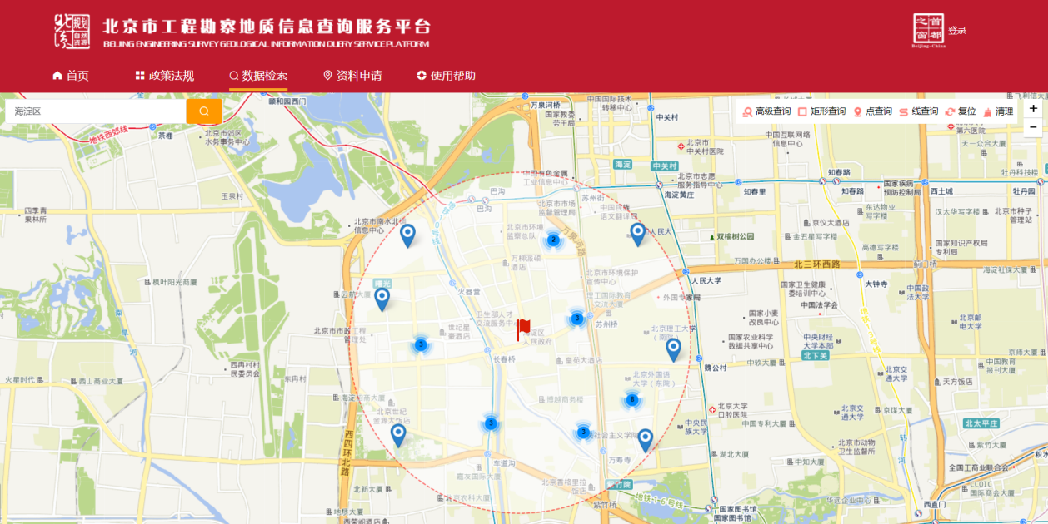
Fig. 6 Inquiring by Place Name
Click on the "Advanced Query" button on the toolbar at the top right of the Data Retrieval Interface, and put a key project information such as a project name or a region name in the box popped up, the System will present you with all the information about the project, including location. See the following figure to see how to conduct advanced query:
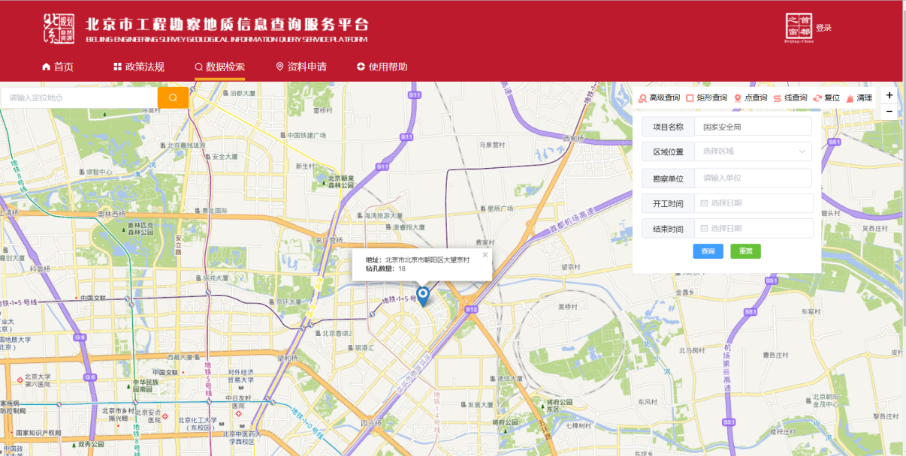
Fig. 7 Advanced Query

Rectangular Query
Click on the "Rectangular Query" button on the toolbar at the top right of the Data Retrieval Interface, then draw a rectangle in the area you want to make a query on the map, the System will present you with all the projects in the rectangular area. See the following figure to find out how to conduct rectangular query: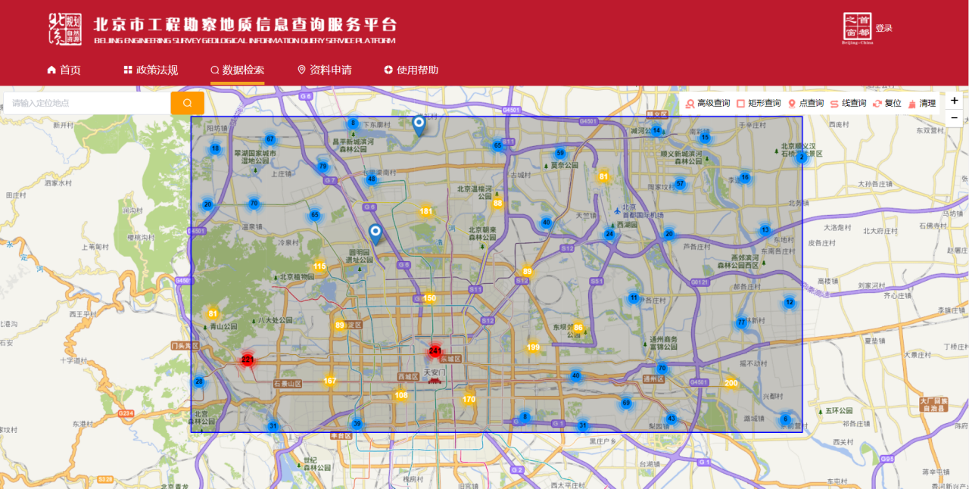
Fig. 8 Rectangular Query

Point Query
Click on the “Point Query” button on the toolbar at the top right of the Data Retrieval Interface, then click on the area you want to make a query on the map, the System will present you with all projects within a certain range of this point. The figures shown on the map represent the number of projects in the place. Click on the figures, the screen will zoom in and display all the projects. Click on the respective landmarks, you'll be able to see the detailed information of the projects, including project name, location, type and number of boreholes. See the following figure to find out how to conduct point query:
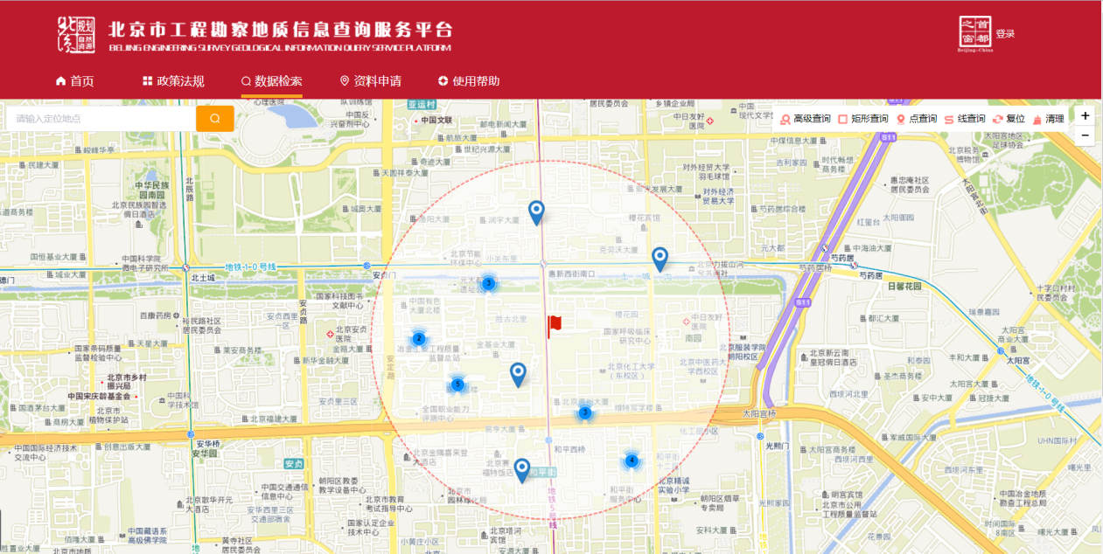
Fig. 9 Point Query

Line Query
Click on the "Line Query" button on the toolbar at the top right of the Data Retrieval Interface, then draw a polyline in the area you want to make a query on the map, the System will present you with all the projects within a certain range of the polyline. The figures shown on the map represent the number of projects in the place. Click on the figures, the screen will zoom in and display all the projects. Click on the respective landmarks on the map, you will be able to see the detailed information of the projects, including project name, location, type and number of boreholes. See the following figure to find out how to conduct line query:
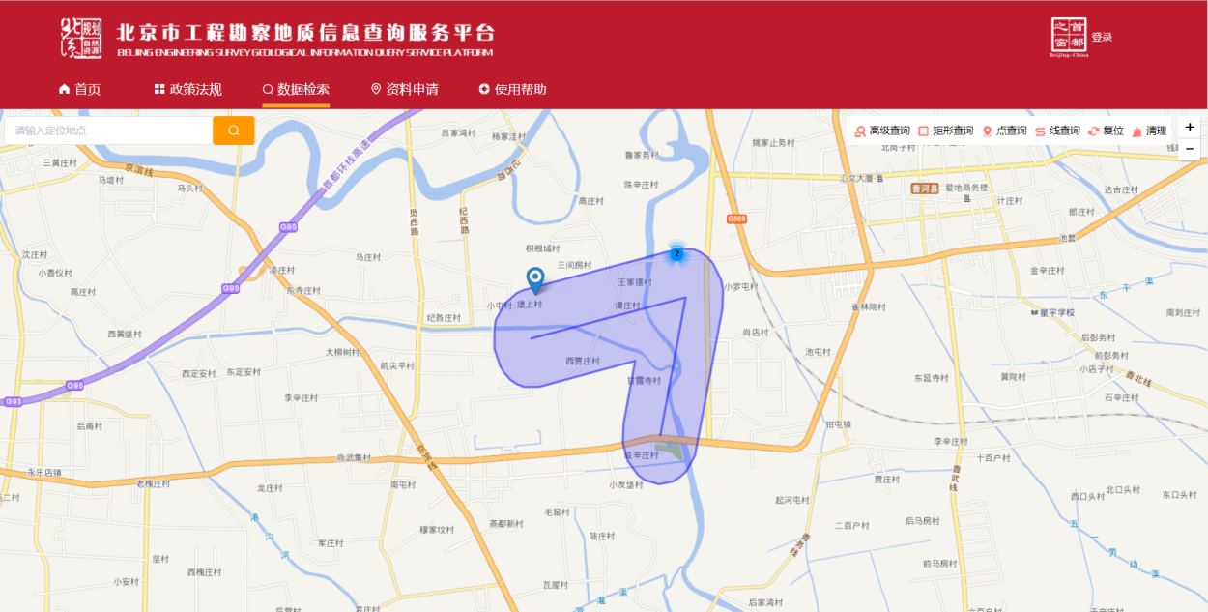
Fig. 10 Line Query

Resetting
Click on the "Reset" button on the toolbar at the top right of the Data Retrieval Interface, the map shown on the screen will restore to the default range. See the following figure for the map after it is being reset:
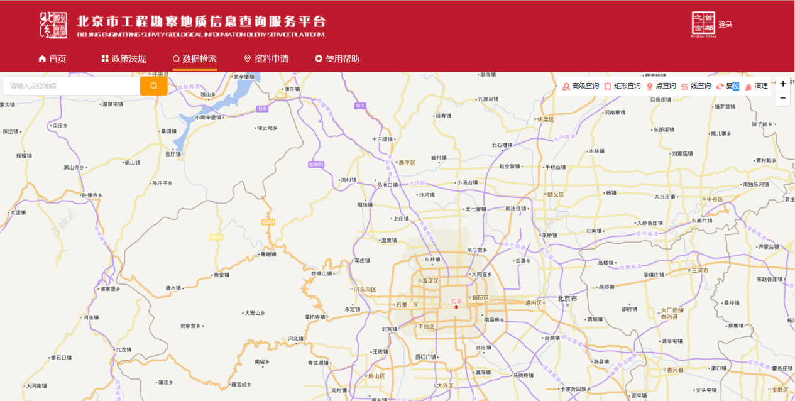
Fig. 11 The Map after it is being reset

Cleaning Query History
If you want to clean query history, click on the "Clean Query History" button on the toolbar at the top right of the Data Retrieval Interface.

Material Request
If you find a project that you are interested in through query and you want to request relevant materials about the project, you can apply for in the Data Application Interface. For the application, you need to first log in to your company's account and then indicate the data that you are applying for and fill out a form.

Data Request
In the Data Application Interface, find the project that you are interested in using the query tools. Click on the project for detailed information, click on the "Load Boreholes" button, the System will present you with all boreholes of the project.
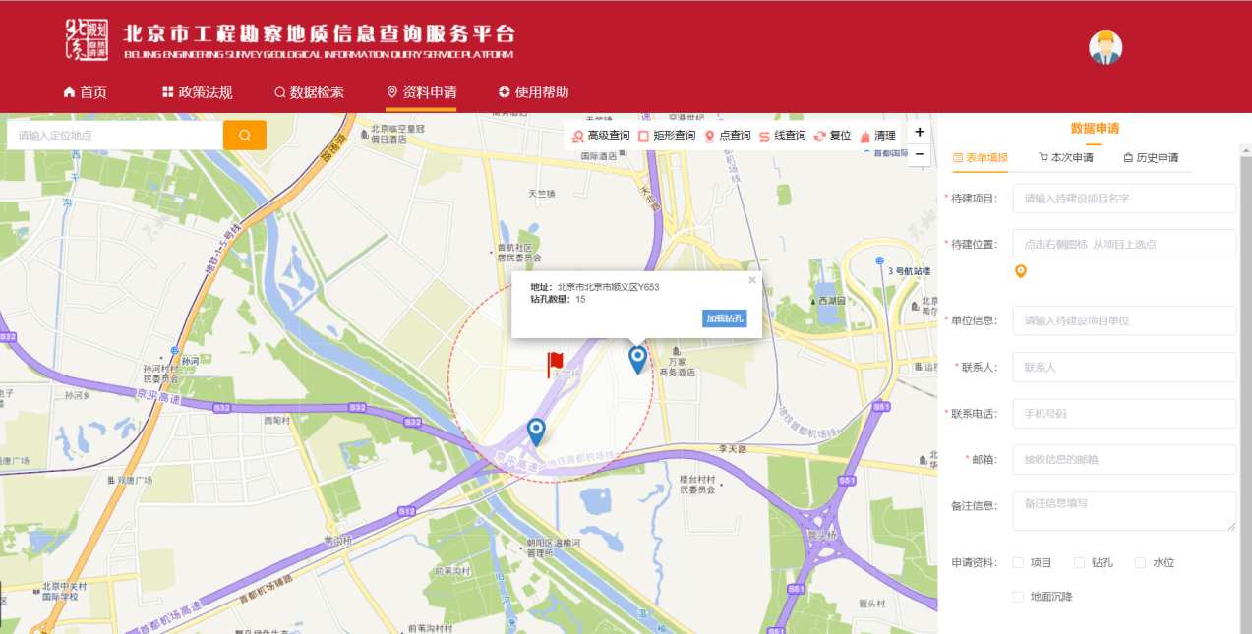
Fig. 12 Load Boreholes
Click on the boreholes the information of which you want to apply for, and then click on the "Apply" button in the interface popped up, a reminder will pop up to remind you to add the borehole into the list of boreholes. When deciding the list, you can check the information of each borehole so as to decide the information of which you are supposed to apply for. Besides, you can also delete certain boreholes from the list.
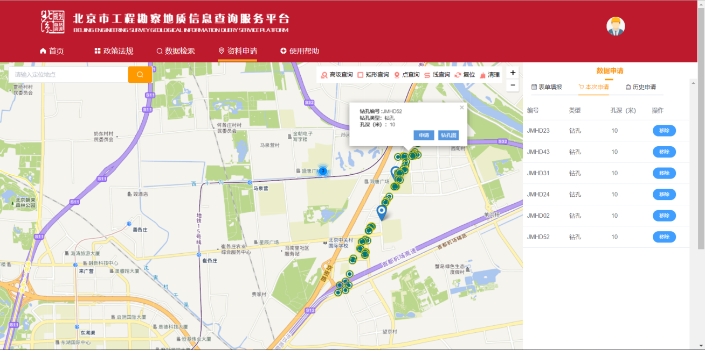
Fig. 13 Data Request
After you add your desired boreholes into the list, you need to fill out a form with the following information: name and location of the project to be constructed, name of your company, your phone number and email address, data type, etc., and upload the detailed data of the project in form of annex. After you complete the form, click on the "Apply Now" button to complete the data application.
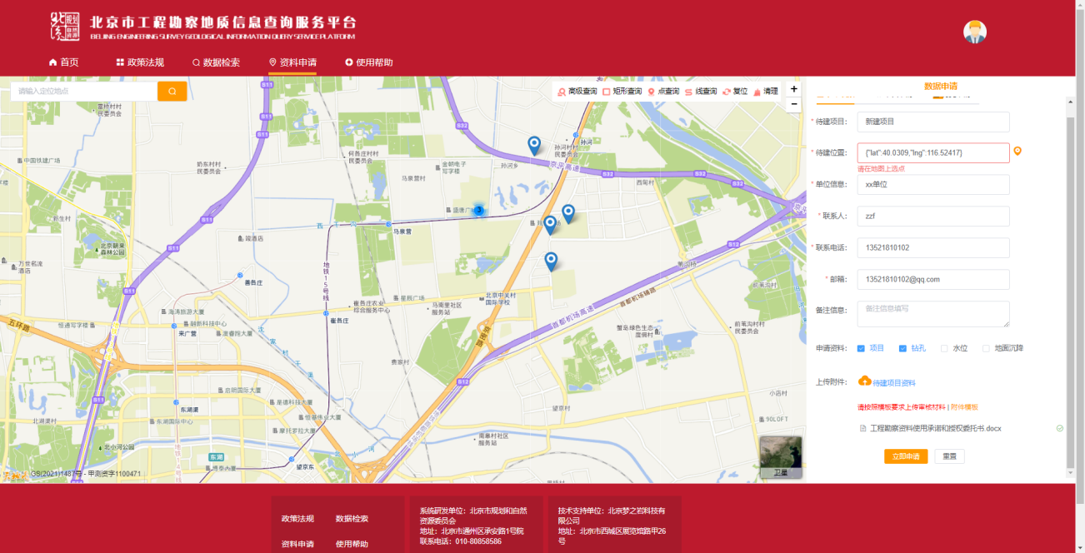
Fig. 14 Filling out the Form
After your application is approved, you will see the applied project records under the Application History tag. The interface is as follows:
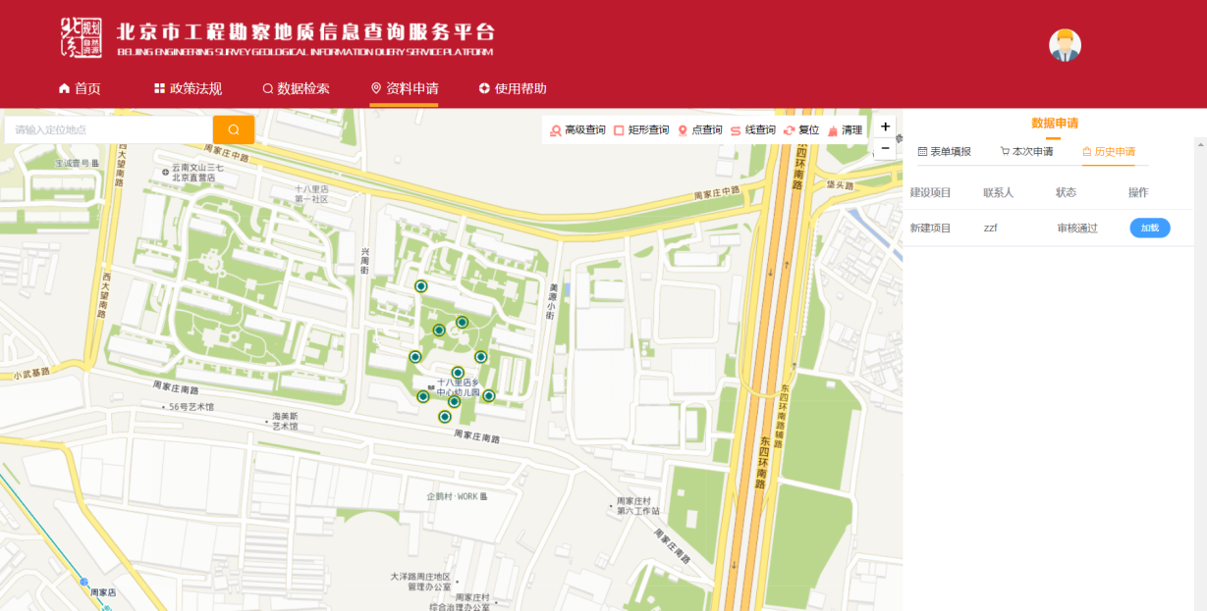
Fig. 15 Application History
Click on the "Load" button in the application history list, the System will jump to the page displaying the locations of applied boreholes. Click on the boreholes on the map, you will be able to view borehole logs, and click on the "Download" button at the top right of the bore log, you can download it in the form of picture to your computer. See the following figure for the details of a borehole log:
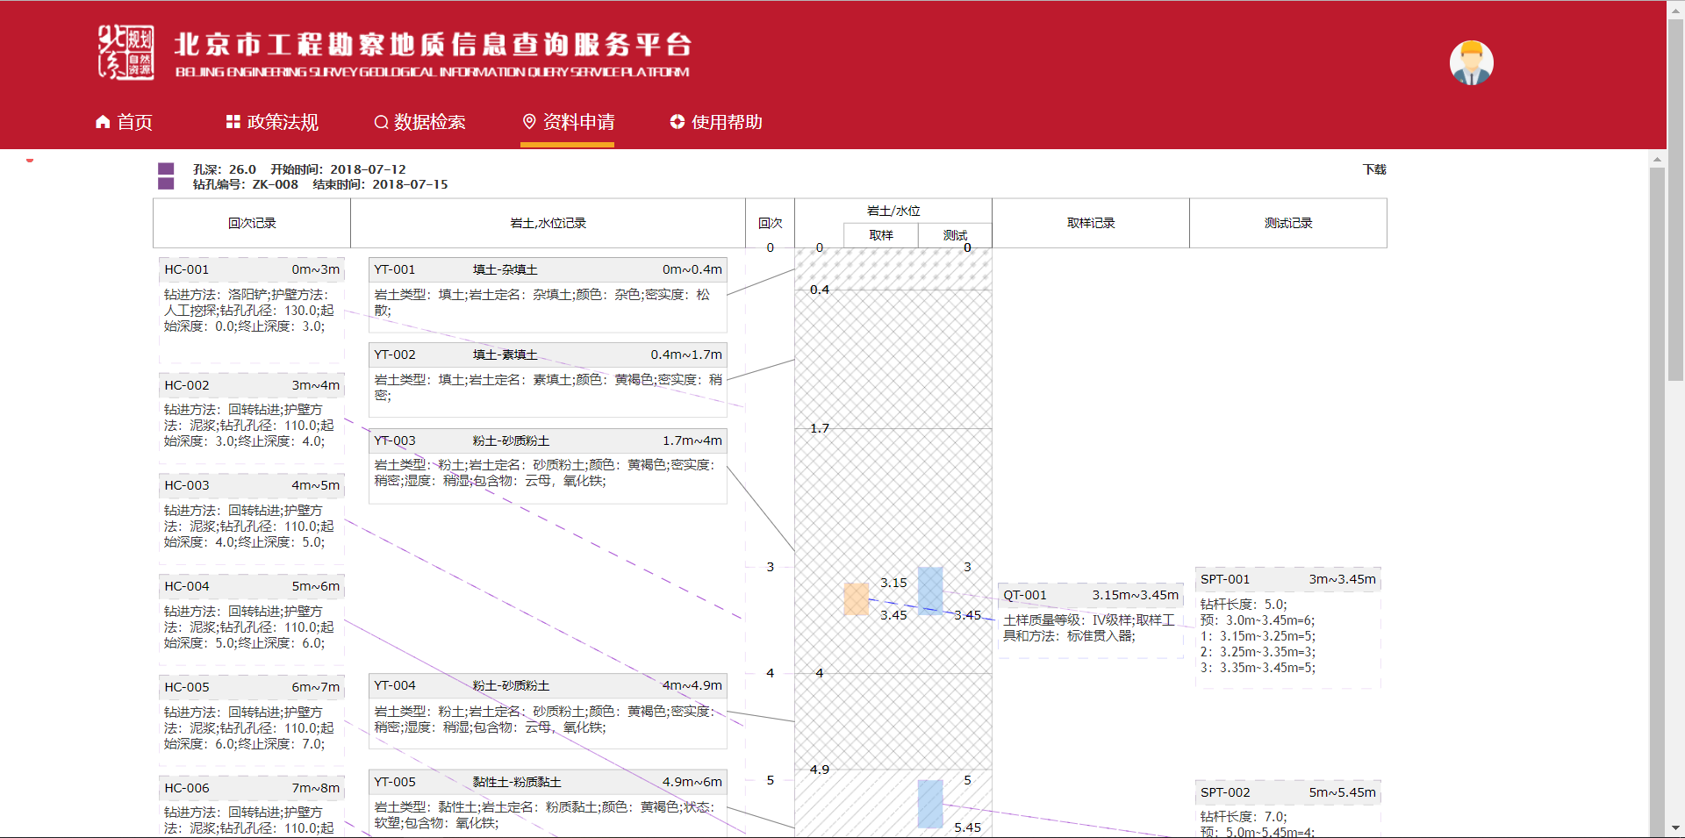
Fig. 16 Borehole Log

